**USER DOCUMENT**

**INTRODUCTION**

GoMart Shopping is a Web and Mobile application that gives customers the convenience online grocery shopping. The user document outlines the requirements and specification of the application development, as well as, a description of usage. The user document details the functionality, that is, what the resulting application is supposed to do; describes the external interfaces which interacts with the users; and outlines possible design constraints imposed on the implementation such as performance, implementation language, input specifications and output expectations

* 1. **Purpose and Scope**

The user document is intended to provide technical assistance to online shoppers of GoMart. Features of the application are described to assist the use with the service.

* 1. **Organization**

**Contents**

1. INTRODUCTION 1

**1.1** **Purpose and Scope** 1

**1.2** **Organization** 2

**1.3** **Points of Contact** 4

**1.4** **Project References** 4

**1.5** **Primary Business Functions** 4

**1.6** **Glossary** 5

2 SYSTEM CAPABILITIES 5

**2.1** **Purpose** 5

**2.2** **Overall Description** 5

**2.3** **Description** 5

**2.4** **Web Page Details** 6

**2.5** **General Description** 10

3 DESCRIPTION OF SYSTEM FUNCTIONS 10

**3.1** **Function the Platform** 10

**3.2** **Detailed Description of Function** 10

**3.3** **Preparation of Function Inputs** 12

**3.4** **Results** 13

4 OPERATING INSTRUCTIONS 14

**4.1** **Initiate Operation** 14

**4.2** **Maintain Operation** 14

**4.3** **Terminate and Restart Operations** 14

5 ERROR HANDLING 14

**5.1** **Help Facilities** 15

* 1. **Points of Contact**

We are currently located in these cities:

|  |  |
| --- | --- |
| **LISBON**  1600+ customers  60+ staff  [**mailto:@mebuynsell_lx**](mailto:@mebuynsell_lx) | **SAN FRANCISCO**  3700+ customers  160+ staff  [mailto:@ mebuynsell _sf](mailto:@%20mebuynsell%20_sf) |
| **BERLIN**  2300+ customers  110+ staff  [**mailto:@ mebuynsell _berlin**](mailto:@%20mebuynsell%20_berlin) | **LONDON**  1200+ customers  50+ staff  [**mailto:@ mebuynsell _london**](mailto:@%20mebuynsell%20_london) |

Help Desk: 00441604390190

Online Support: GoMart.com/support

* 1. **Primary Business Functions**

The end user plays a role in the business goals of the organization by providing feedback on how to best improve the software. The end user provides value in real-world use of the application. Information gathered are in the following areas:

* Information Technology
* Research and Development
* Customer Service
* Distribution
* Quality Assurance
* Marketing
  1. **Glossary**

*Administrator*- a qualified webmaster that manages the content of the website. The administrator may be a single entity, or any individual assigned with the role with access

*Front End*- the content the end user interacts with

*GoMar*t-

*Customer*- an end user who not only uses the application, but makes a purchase

*End user*- any individual who uses the application

*Moderator*-

*User Document-* provides the information needed to use the product/service

1. **SYSTEM CAPABILITIES**

The system or platform is a web-based application which serves the needs of online customers. GoMart manages orders from customers and provides inventory control for distribution centers.

* 1. **Purpose**

The purpose of the system is to increase the point of customer choices, reduce time in shopping, and the efficiency in purchasing groceries. The application quality has been designed to provide a pleasing user experience. Navigation is simple, and the website layout is presented as tabbed menus to direct the user to the appropriate task section. The application was tested against predetermined criteria to ensure functionality on different platform devices.

* 1. **Overall Description**

GoMart’s website development involves a multi-tiered architecture, server, and client-side scripting techniques.

* 1. **Description**

System is integrated with external applications to communicate directly and automatically with supporting vendors without the need of an administrator for input. These vendors include online payment systems the two systems work in synergy without the customer abandoning the GoMart platform. The integration of logistics provides for courier service once the order is confirmed for pickup at the distribution center.

* 1. **Web Page Details**
* Home Page- the start-up page of the web application
* AboutUs Page- provides the company overview
* Grocery Page- the product catalogue and the cart
* OrderUs Page- the transaction handling
* ContactUs Page- to contact administrator for queries
* Administrator Page-
* Search page- finding the desired product by entering a keyword
* Login Page
* Register Page
* Track

HOME PAGE

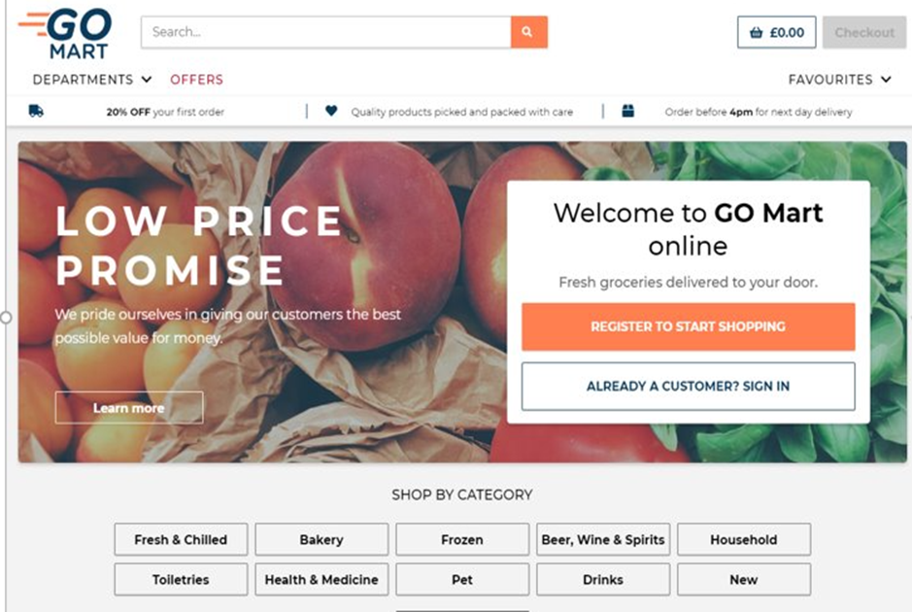

The home page announces both individaual and group promotions. New products and special offers are advertised on this page. The login andf registration portals can be found on this page.

SEARCH PAGE

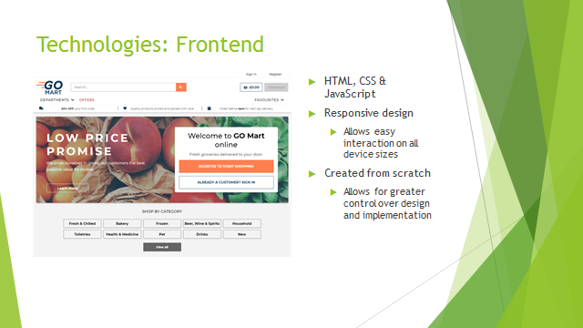

GROCERY PAGE

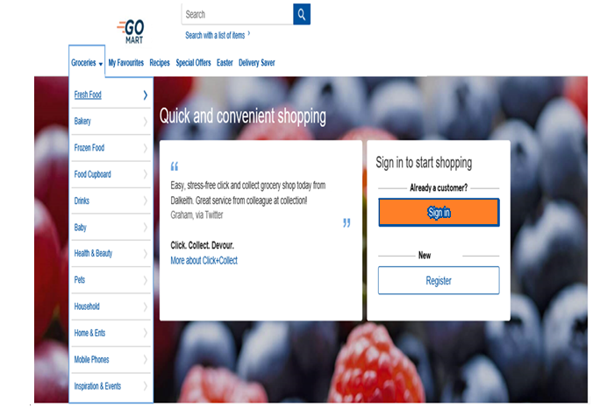

Selection of the grocery tab reveals the various product categories.

ORDER US

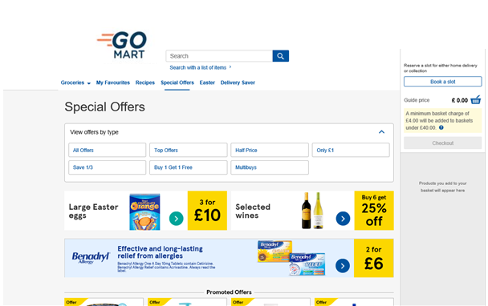

CONTACT US

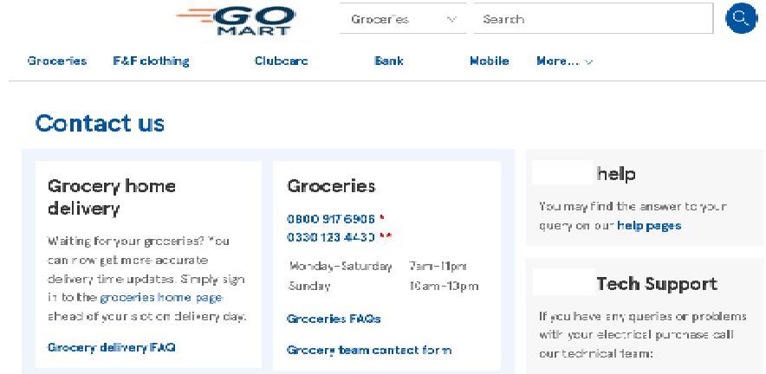

ADMINISTRATOR PORTAL 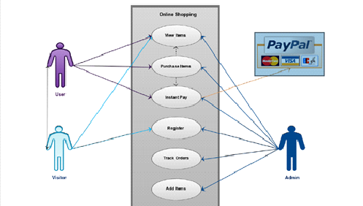

The administrator portal involves the back end of the system. The administrator portal handles product and content management. The administrator maintains the site and updates it in real-time and provides customer support. Sales, products, customers, and marketing data is tracked. Analytics are ran and reports generated.

LOGIN

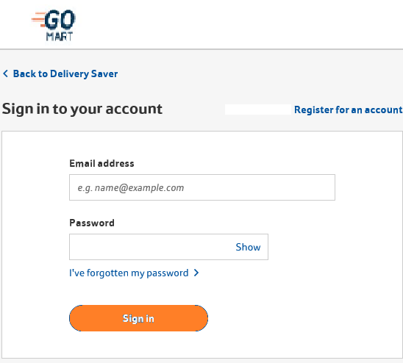

REGISTER

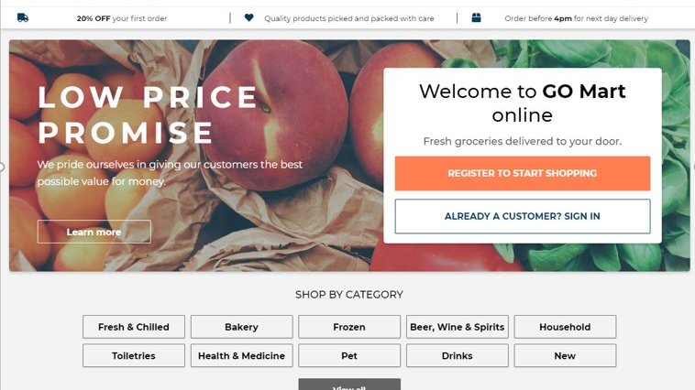

User registration is free

DELIVERY

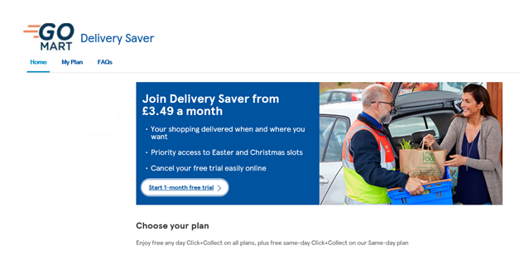

* 1. **General Description**

The potential customer visits the website and registers. The customer searches and selects grocery products, that is placed in the virtual cart. Payment is made. Payment is received by the outsourced payment center and the order is received by the distribution center for pickup and delivery of the order. The administrator manages the website and collects information that may reveal information about shopping patterns.

The selected product may be collected in shopping cart. At checkout, products in the shopping cart will presented as an order, where the shipping information and payment are provided by the customer. The customer then confirms the order for delivery

1. **DESCRIPTION OF SYSTEM FUNCTIONS**

This section describes each specific function of the system.

* 1. **Function the Platform**

The platform gives its users and/or customers a wider range of options compared to visiting a physical grocery store, for example:

* A mobile shopping option which can be done from anywhere and at any time of the day.
* The detailed product description.
* Advanced navigation and search functions.
* Free and competitive shipping options.
* Customer reviews of the products.
* A fast guest check-out option.
  1. **Detailed Description of Function**

In the proposed system customer need not go to the shop for buying the products. He can order the product he wish to buy through the application in his Smartphone or PC. The shop owner will be the administrator of the system. Shop owner can appoint moderators who will help owner in managing the customers and product orders. The system also recommends a home delivery system for the purchased products.

**LOG IN**

This feature is the entry point into the system by a return user. A user must log in with their user credentials after registration. If the credentials are invalid, the user is not permitted to enter the system. The customer gets to setup their account in the system and can continues to purchase items for delivery. On the back end, the administrator manages the input data (updating, description, etc.).

**INPUT**

Input design is the link that ties the information system into the world of its users. The input design involves determining the inputs, validating the data, minimizing the data entry and provides a multi-user facility.

Inaccurate inputs are the most common cause of errors in data processing. Errors entered by the data entry operators can be controlled by input design. The user-originated inputs are converted to a computer-based format in the input design. Input data are collected and organized into groups of similar data. Once identified, the appropriate input media are selected for processing. All the input data are validated and if any data violates any conditions, the user is warned by a message. If the data satisfies all the conditions, it is transferred to the appropriate tables in the database. In this project, the user details are to be entered at the time of registration. A page is designed for this purpose which is user friendly and easy to use. The design is done such that users get appropriate messages when exceptions occur.

**OUTPUT**

Computer output is the direct source of information to the user. Output design is a very important phase since the output needs to be in an efficient manner. Efficient and intelligible output design improves the system relationship with the user and helps in decision making. Allowing the user to view the sample screen is important because the user is the ultimate judge of the quality of output. The output module of this system is the selected notifications.

**DATABASE**

Databases are the storehouses of data used in the software systems. The data is stored in tables inside the database. Several tables are created for the manipulation of the data for the system. Two essential settings for a database are

Primary Key- the field that is unique for all the record occurrences.

Foreign key-the field used to set relation between tables.

Normalization is a technique to avoid redundancy in the tables.

* 1. **Preparation of Function Inputs**

The administrator role has privileged access to this application portal. The administrator has all the information about all the users and their order.

This module is divided into four sub-modules.

1. Moderator
2. Manage Products
3. Manage Users
4. Manage Orders

**MODERATOR**

A moderator is a staff personal who can manage orders for the time being. Moderators can reduce the work load of the administrator. A moderator has all the privileges an administrator having except that of managing other moderators. A moderator can add products and users, review orders and edit user profile.

* Manage products
* Manage users
* Manage orders

**MANAGE PRODUCTS**

* Add Products

The shopping cart project contains different kind of products. The products can be classified into different categories by name. the administrator can add new products into the existing system with all its details including an image.

* Delete Products

Administrator can delete the products based on the availability.

* Search products

Administrator will have a list view of all the existing products. They can also search for a product by name and amend the status as needed.

**MANAGE USER**

* View Users

The administrator will have a list view of all the users registered in the system.

Administrator can view all the details of each user in the list except password.

* Add Users

Administrator has privileges to add a user directly by providing the details.

* Delete & Block Users

Administrator has a right to delete or block a user. The default status of a new user registered is set as blocked. The administrator must accept the new user by unblocking them.

**MANAGE ORDERS**

* View Order

Administrator can view the Orders which is generated by the users. Administrator verifies the details of the purchase.

* Delete order

Administrator deletes request from the orders list when the product is picked up for delivery.

* 1. **Results**

This section describes expected results of the function. Include the following in the description as applicable:

* Description of results, using graphics, text, and tables
* Form in which the results will appear
* Output form and content
* Report generation
* Instructions on the use of outputs
* Restrictions on the use of outputs
* Relationship of outputs to inputs
* Function-specific error messages
* Function-specific or context-sensitive help messages associated with this function
* Examples

**4 OPERATING INSTRUCTIONS**

This section provides detailed, step-by-step system operating instructions.

* 1. **Initiate Operation**

This section contains procedures for system logon and system initialization to a known point, such as a system main menu screen. This initialization procedure should describe how to establish the required mode of operation and set any initial parameters required for operation. Software installation procedures should be included if the software is distributed on diskette and should be downloaded before each use.

* 1. **Maintain Operation**

This section defines procedures to maintain the operation of the software where user intervention is required.

* 1. **Terminate and Restart Operations**

This section defines procedures for normal and unscheduled termination of the system operations and should define how to restart the system.

1. **ERROR HANDLING**

Should you encounter any errors, kindly refresh the page. If the error message appears again, quit the process, exit the tab and start the process all over again since this might a user error.

All server and service errors will be handled from our offices

Contact the nearest office (see section **1.3)** close to you for assistance if error continues to persist.

* 1. **Help Facilities**

Please contact of offices for a 24/7 help if the need be.